**Guided Capstone Project Report**

Big Mountain Resort, a ski resort located in Montana,serviced by 11 lifts, 2 T-bars, and 1 magic carpet for novice skiers.Big Mountain Resort has recently installed an additional chair lift to help increase the distribution of visitors across the mountain. This additional chair increases their operating costs by $1,540,000 this season so now Big Mountain Resort wants to maintain their annual profit of 9.2 % even after increased operating cost due to installation of additional chair lift. One of the suggestions is to increase the ticket price to increase the revenue but Big Mountain Resort needs some guidance on how to select a better value for their ticket price or cut costs without undermining the ticket price .

Therefore, using the data available from other skiing resorts, I designed a Linear-regression model to predict the price of tickets on the weekend for Big Mountain Resort. Based on the linear regression model my recommendation is to increase the price of tickets on weekends from 81 $ to 92.25 $.

But the big question is whether it is a good idea to increase the price of the tickets as Big Mountain suspects it may not be maximizing its returns, relative to its position in the market. Therefore, we further analyzed the given market data and did some statistical analysis on that data.

Some following suggestions/scenarios we analyze:

1. **Close up to 10 of the least used runs.**

The model says closing one run makes no difference. Closing 2 and 3 successively reduces support for ticket price and so revenue. If Big Mountain closes down 3 runs, it seems they may as well close down 4 or 5 as there's no further loss in ticket price. Increasing the closures down to 6 or more leads to a large drop.

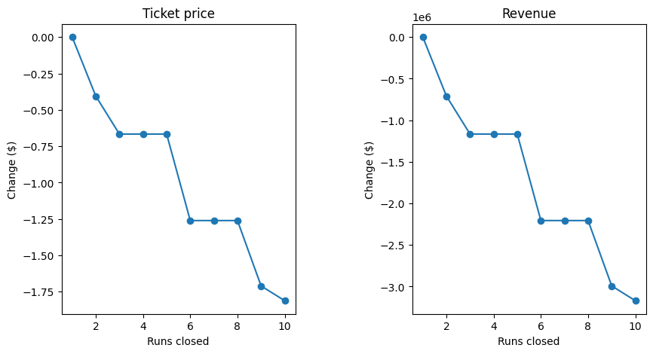

1. **Big Mountain is adding a run, increasing the vertical drop by 150 feet, and installing an additional chair lift.**

This scenario increases support for ticket price by $1.99. Over the season, this could be expected to amount to $3474638

1. **In this scenario, you are repeating the previous one but adding 2 acres of snow making.**

This scenario increases support for ticket price by $1.99.Over the season, this could be expected to amount to $3474638.

Such a small increase in the snow making area makes no difference!

1. **This scenario calls for increasing the longest run by .2 miles and guaranteeing its snow coverage by adding 4 acres of snow making capability.**

No difference whatsoever. Although the longest run feature was used in the linear model, the random forest model (the one we chose because of its better performance) only has longest run way down in the feature importance list.

**Summary**

There are two gaining possibilities

**Price Increase:**

The best model predicts a price of 95.87 USD, while the actual price is 81.00 USD. This suggests that there is room for an increase in ticket prices. With an expected mean absolute error of 10.39 USD, a 5 USD increase in ticket prices could potentially result in a total revenue increase of 7.5 million USD per year. This calculation assumes an average of 350,000 guests staying for 5 days each year.

**Cost Savings:**

Several change proposals were noted for potential cost savings: Adding a run, increasing the vertical drop by 150 feet, and installing an additional chairlift could result in a price increase of 1.99 USD per ticket. This change alone could potentially sum up to 3.5 million USD in additional revenue per year. Adding 2 acres of snowmaking does not appear to have an incremental effect on ticket prices. Closing up to 10 of the least used runs may result in a slight price decrease. This option can be considered if the price decrease is minimal and the cost savings from reduced maintenance and operational expenses outweigh the potential revenue loss.